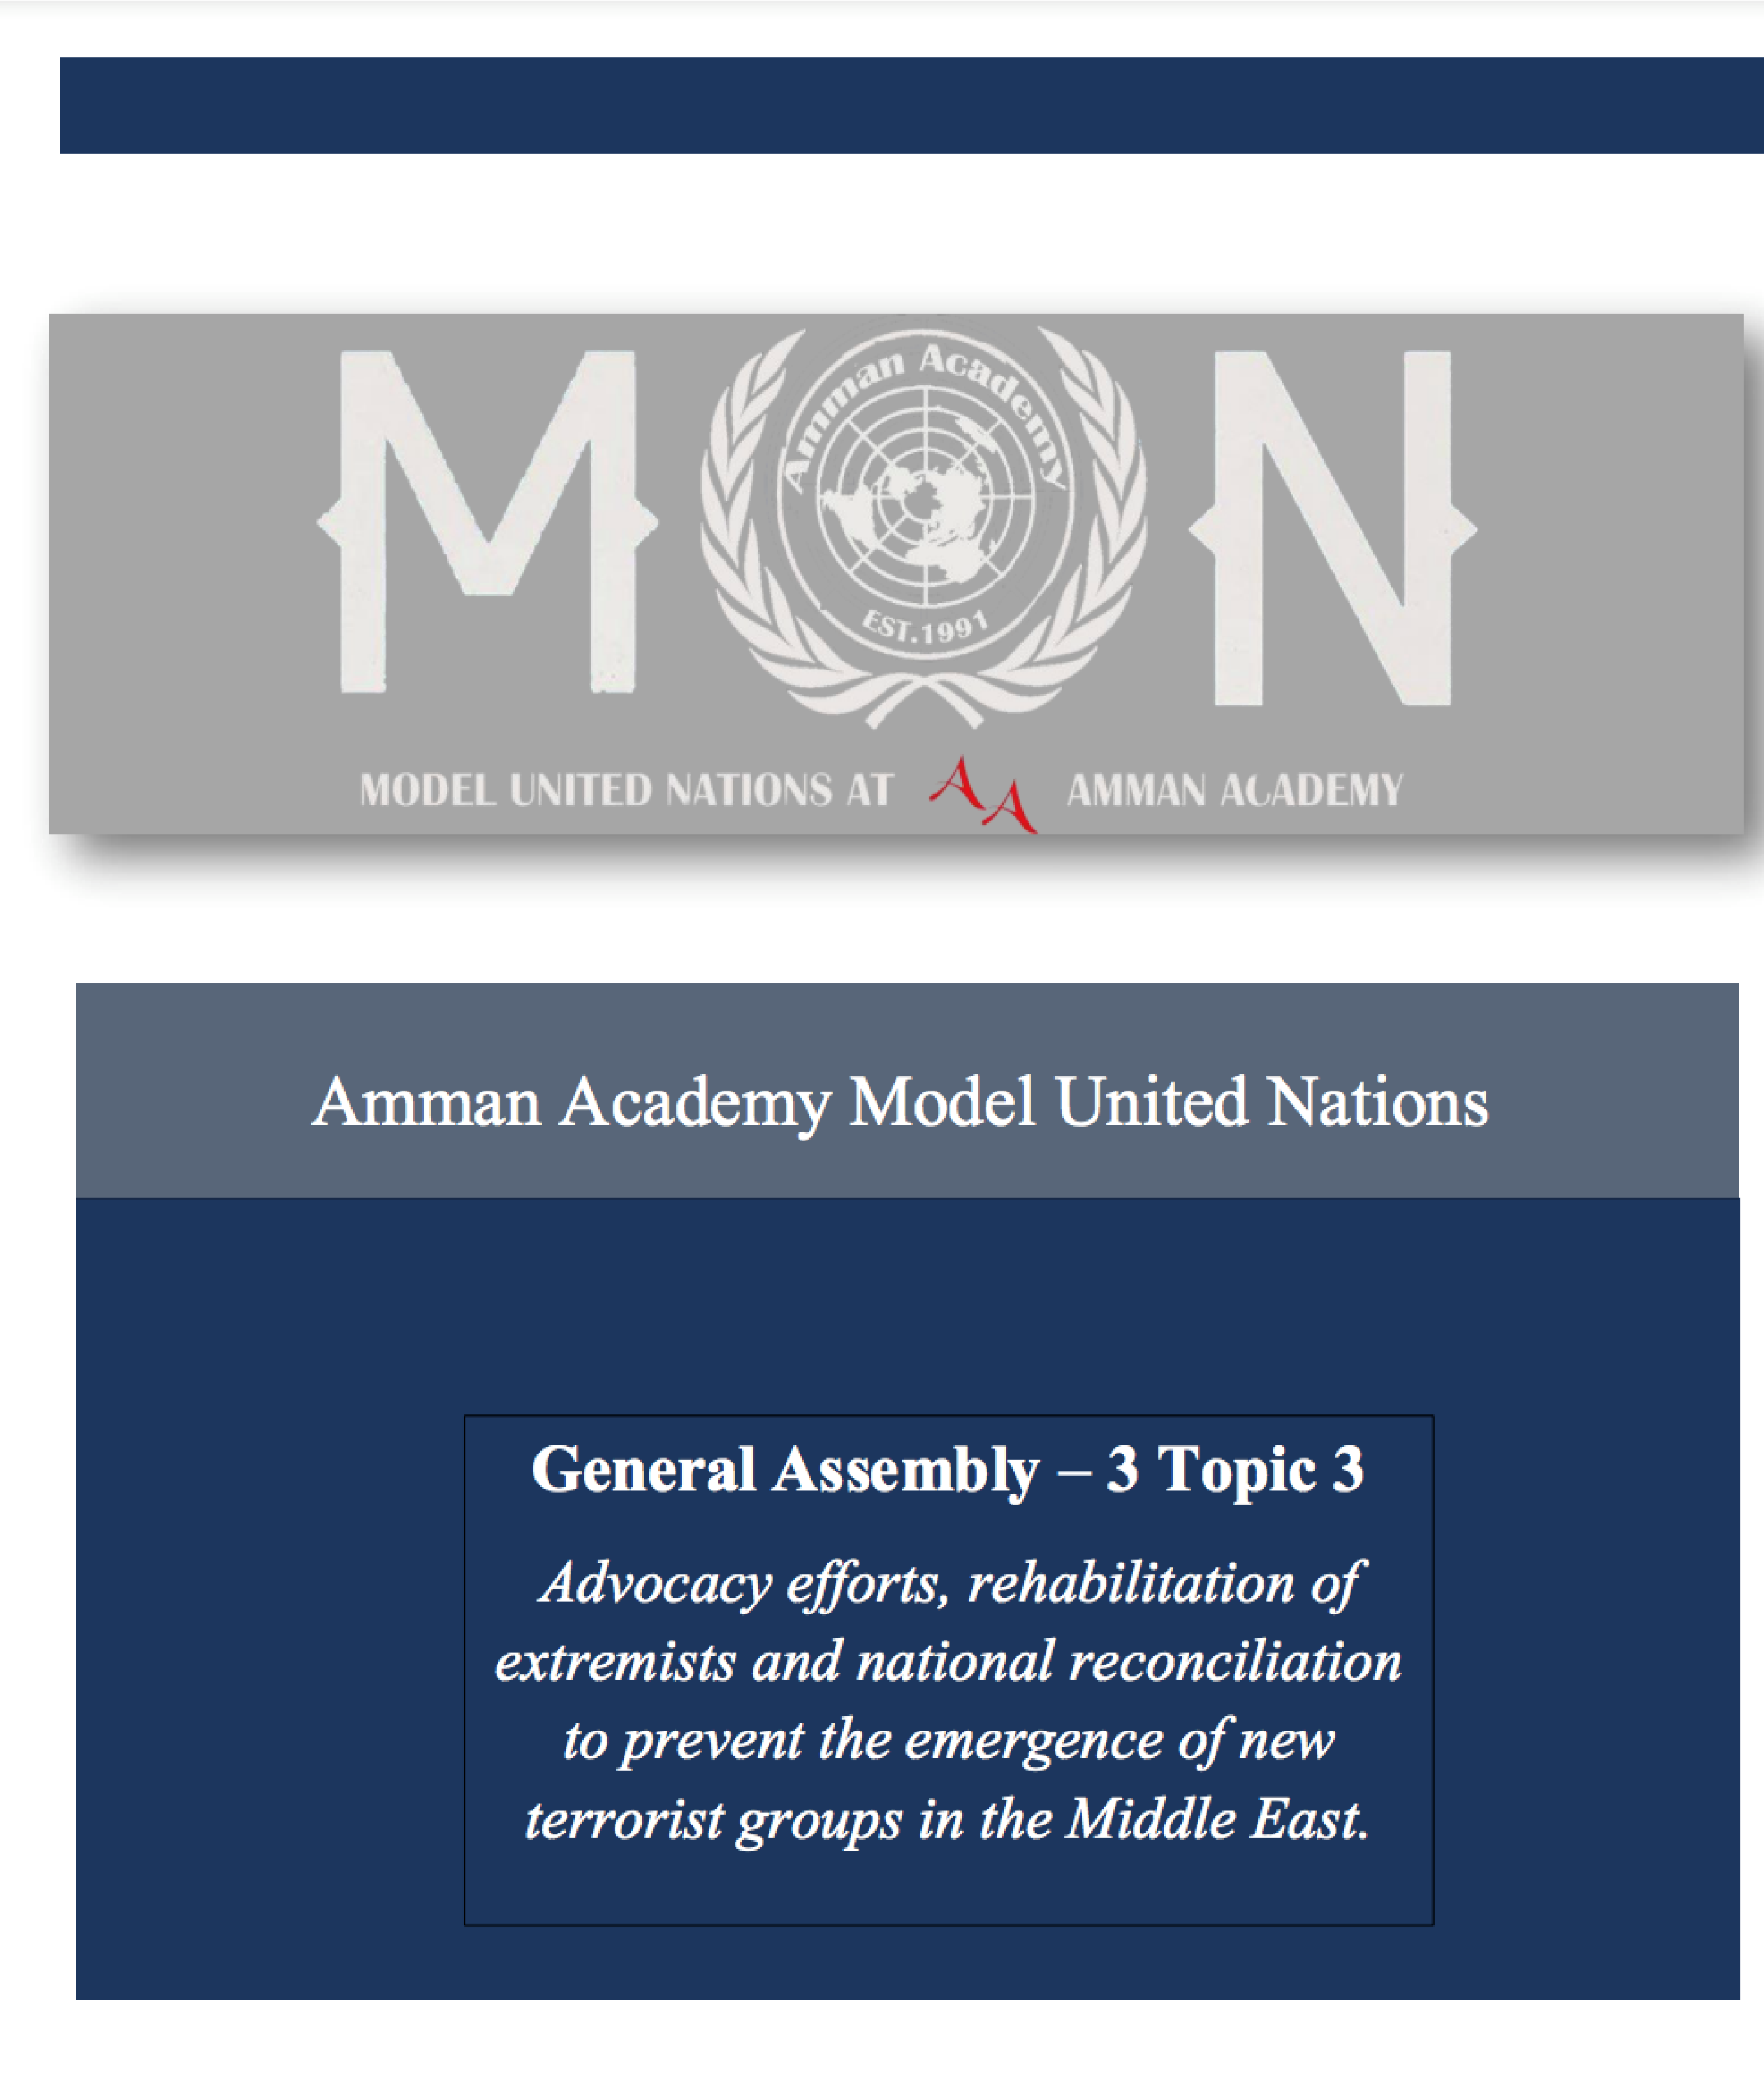

Topic 1:

Tackling the hyperinflation crisis in Lebanon

**Introduction**

Lebanon is on the brink of an economic collapse. The hyperinflation in Lebanon would average 178% in by the end of this year, up from around 155% last year. Lebanon is the third country in the world with the most debt and have been fighting governmental corruption and hyperinflation for a number of years. Their currency is slowly declining in value and the percentage of the population likely to fall into poverty is at a whopping 75%. The corrupt Lebanese government is failing to make payments and they have recently failed to make a 1.2-billion-dollar payment towards foreign bonds. Also, their sectarian government resulted in a lack of equity and stability. For these reasons, an uprising occurred in August of 2019 which led to a new government being formed in 2020. Unfortunately, Lebanon is continuing to fail at controlling the prices of their food and providing governmental services to their citizens such as water, electricity, and garbage collection services. These governmental failure has resulted in hyperinflation in the country.

**Definition of Key Terms**

Hyperinflation (noun):

Hyperinflation is very high, and typically accelerating, inflation. It increases in the price of goods causing people to minimize their holdings in that currency as they usually switch to more stable foreign currencies.

Sectarian government (noun):

A form of government that ensures the representation of different religious groups.

Corruption (noun):

Dishonest or fraudulent conduct by those in power.

Currency (noun):

The system of money in general sue in a specific country.

**General Overview**

Hyperinflation is usually a direct effect of countries printing more of their currencies increasing their cash supply and decreasing its value. This causes the state’s prices to skyrocket, and many families start facing financial issues. This also becomes a burden on the government as they often start to have trouble supplying their citizens with their daily needs. For this reason, citizens often rebel against the government leading to an entire political, economic, and social crisis. One sate that is currently facing this issue is the middle eastern country of Lebanon where 3 quarters of Lebanese residents have fallen into poverty due to this hyperinflation crisis.

Lebanon is on the brink of economic collapse. Lebanon’s debt is 150% of its national output. Its local currency has lost over 90% of its value since the year 2019. The consumer price index rose 137.8% from a year earlier in August 2021, compared with 123.4% rise in July of 2021, according to the Lebanon Central Administration of Statistics. Between August and September of 2021, consumer prices rose 10.25%.

The price of food is has skyrocketed as well. Between September and August of 2021, the prices of food have increased by 20.82% leaving many Lebanese families to be unable to provide sufficient meals for their families. This occurred for a number of reasons. One of them being that Lebanon is the most in debt country in the world and it has recently failed to make a 1.2-billion-dollar payment for foreign bonds.

Furthermore, the banking system has been sued to finance unsustainable spending. Banks are limiting the number of US dollars which clients can withdraw from their own account as Lebanon is becoming heavily reliant on the US dollar. Moreover, Government mismanagement and corruption continue to be a part of Lebanon’s hyperinflation crisis and politicians are doing very little to mitigate the situation. Governments are failing to provide services like 24/7 electricity and garbage collection services. Lebanon’s corruption is fueled by its own political system, which is a sectarian government. Some claim that this encourages patronage and creates a political class that looks after its own sect interest rather than Lebanon as a whole. In August 2019, there was an uprising that targeted Lebanon and its political system itself. It was directed towards the financial issues and the sectorial issue sin the government. The government response was a resignation. In early 2020, a new government was formed by Prime Minister Najib Mikati, but people did not agree with his system.

Now, the government is debating a multimillion dollar bail out from the international monetary fund due to the fact that Lebanon is anticipated to have the world's second-highest inflation rate this year, after only Sudan.

**Major Parties Involved**

The Lebanese government:

The Lebanese government has been failing to mitigate through the situation. They have failed to provide services such as water, 24/7 electricity, and garbage collection services. A new government was formed in 2021 as result of the uprising, but they are yet to get the hyperinflation crisis under control.

Bank Audi:

Bank Audi is the biggest bank in Lebanon, and they initiated the practice of limiting the number of US dollars withdrawable by each bank account in attempts to preserve a currency that Lebanon has become highly dependent on. Bank Audi has reported numerous times on the surge in inflation to the depreciation of the Lebanese lira, and the removal of subsidies on energy and pharmaceutical products.

**Timeline of Key Events**

|  |  |
| --- | --- |
| **Date:** | **Events:** |
| August 2019 | Hyperinflation crisis in Lebanon first became evident when the Lebanese pound started to decrease in value. This was also when the uprising occurred against the Lebanese government due to their corruption and inability to get the hyperinflation under control. |
| Early 2020 | New government is formed by Najib Mikati. |
| 2020 | Banks around Lebanon start limiting the number of US dollars each account can withdraw. Government continues to fail at providing basic services (water, heat electricity, garbage collection services, etc.) |
| 2020 | Lebanon fails to make 1.2-billion-dollar payment towards foreign bonds. |
| July- August 2021 | Consumer index prices rise to 123.4% |
| August- September 2021 | The consumer price index rises 10.25% to 137.8% and food prices rise by 20.82% |
| 2022 | 75% of Lebanese residence claim to be in poverty and government is planning on debating a multimillion dollar bail out from the international monetary fund. |

**Previous attempts to resolve the issue**

The only measure that has been taken in the past in attempts to help the state of Lebanon recover from their hyperinflation crisis was the government’s resignation in 2019 after the uprising, due to corruption and patronage, and the Prime Minister, Najib Mikati, forming a new government. This was supposed to be a fresh start for Lebanon, and it would keep the government from constantly being accused of corruption, but the Lebanese citizens did not were very fond of this government.

**Possible Solutions**

Hyperinflation in Lebanon can be stopped by severe measures such as implementing shock treatment by cutting government spending or changing the currency base completely. Fully implementing the US dollar would decrease the effects of the weak Lebanese pound and prices of goods and services would decrease.

Furthermore, following through with the multimillion dollar bail out from the international monetary fund. This bailout is designed to put government finances on a sustainable footing and restore growth therefore allowing Lebanon to rebuild its economy and control their hyperinflation.

**Bibliography:**

Al Jazeera. “Lebanon's Inflation Rate Is Worse than Zimbabwe's and Venezuela's.” *Business and Economy News | Al Jazeera*, Al Jazeera, 21 Sept. 2021, https://www.aljazeera.com/economy/2021/9/21/lebanons-inflation-rate-is-worse-than-zimbabwes-and-venezuelas.

Derhally, Massoud A. “Lebanon Expected to Record Second-Highest Inflation Rate Globally in 2022.” *The National*, The National, 17 Aug. 2022, https://www.thenationalnews.com/business/economy/2022/08/17/lebanon-expected-to-record-second-highest-inflation-rate-globally-in-2022/.

Deutschewelleenglish, director. *YouTube*, YouTube, 11 July 2020, https://www.youtube.com/watch?v=2FKZ4_LgEUM. Accessed 16 Nov. 2022.

[Lebanon's Economic Update — April 2022 (worldbank.org)](https://www.worldbank.org/en/country/lebanon/publication/economic-update-april-2022)

[2022 Lebanon Crisis Response Plan (LCRP) | United Nations in Lebanon](https://lebanon.un.org/en/172232-2022-lebanon-crisis-response-plan-lcrp)

[Lebanon: UN expert warns of ‘failing State’ amid widespread poverty | OHCHR](https://www.ohchr.org/en/press-releases/2022/05/lebanon-un-expert-warns-failing-state-amid-widespread-poverty)

[LEBANON - ESCWA (unescwa.org)](https://www.unescwa.org/unbis/lebanon)

[The New Humanitarian | Lebanon’s economic collapse prompts rise in gender-based violence](https://www.thenewhumanitarian.org/news-feature/2022/10/4/Lebanon-economic-collapse-gender-based-violence)